**Adaptation and Competition in Avida-Ed**

**Rachel Edidin**

**Abstract**

This research aimed to study competition in different environments among Avidians, the digital organisms of the Avida-Ed software. Avidians were evolved in two different environments and then competed against each other in each of the environments in which they evolved. The first part of the experiment compared dish size. Avidians were evolved in small and large dishes and then competed in small and large dishes. Regardless of the competition environment, the Avidian who evolved in a large dish always outcompeted the small-dish Avidian due to the larger range in fitness level the larger dish produced. The second part of the experiment compared Avidians who evolved in an environment with either all or no resources present, and then competed in both environments. In this case, we found that the organisms competed best in the environment they evolved in. The ability to perform functions, or metabolize the resources effectively, was much more pronounced in the organisms that evolved with resources present. This ability is a substantial advantage when competing in an environment with resources present; however, this is an unnecessary cellular process when no resources are present, which is why those organisms fared worse in competition in a resource-free environment. These patterns are observable and have applications outside of the digital lab bench, such as in native and invasive plants.

**Introduction**

Understanding competition is critical for understanding both inter- and intra-species interactions. According to the Competitive Exclusion Principle, two organisms cannot occupy the same niche at the same time. Thus, they must compete for resources such as shelter, air, food, and water (Brooker et al., 2020). This paper will focus on competition in bacteria, modeled with the Avida-Ed software (Pennock, 2007). Our experiments look at competition in the context of experimental evolution, where certain organisms evolve to live better in certain environments, and then are able to outcompete individuals who are not adapted to that environment. Evolution is not something that can be done intentionally, but over time organisms that have heritable traits which improve survival will reproduce more, and thus these favorable traits increase in frequency (Brooker et al., 2020).

Our experiment focuses not only on the relative fitness conferred by such traits, but also if these traits give organisms better survivability in certain environments compared to organisms lacking said traits. Bernhardt et. al examined whether or not organisms were able to evolve in response to resource availability (2020). It was found that organisms could gain adapted traits that potentially made them more successful competitors in a given environment characterized by resource availability. When organisms “grow up” over generations without certain resources, they have been observed to be able to adapt to use “alternative” resources and are thus more successful in certain resource-poor environments than organisms that had not adapted in such a way (Bernhardt et. al, 2020).

Our experiment also examines whether dish size is a parameter that determines evolutionary success. On a broad scale, species inhabiting large physical spaces have more genetic diversity than those occupying smaller spaces, such as a species living on the mainland compared to the same species on an island (Frankham, 1997). Increased genetic diversity is generally associated with better fitness as organisms are more likely to be able to adapt to specific niches. However, it was observed that organisms from islands were successfully introduced to mainland at a similar rate as organisms from the mainland were successfully introduced to islands (Simberloff, 1995). Thus, being from a larger environment may be a marker of but does not necessarily indicate competitive success.

We expect that adaptation and competitive advantage can also be observed in Avida-Ed organisms, or Avidians. We hypothesize that Avidians that evolved under certain environmental conditions will fare better when competing in the same conditions, compared to individuals who did not evolve with the same parameters. Our parameters of interest are resource availability and dish size. In order to examine competition and resource availability, we will grow organisms in both resource-poor and -rich environments and compete them against each other in resource-poor and -rich environments. We predict that Avidians that grew up in environments with specific resource availability will fare better when placed back in that environment, compared with Avidians that did not. To examine effects of dish size, we will evolve organisms in dishes of different sizes, then compete both organisms in each dish size and see which fares better. We predict that an organism that grew up a dish of a given size will outcompete an organism that did not grow up in a dish of that size. The “success” of Avidians will be measured by the proportion of the dish each ancestor offspring takes up. Through these competition experiments, we hope to draw conclusions about the extent to which individuals can become better suited for better environments, which can be observed both in nature and in these digital organisms.

**Materials and Methods**

*Avida-Ed*

All described steps were performed using Avida-Ed software, which models digital organisms and allows for the changing of parameters such as dish size, resource availability, mutation rate, and more (Pennock, 2007). For all experiments, the original ancestor was the “ancestor” from Avida-Ed, the per site mutation rate was set at 2%, and the offspring were placed near their ancestor.

*Dish Size Competitions*

The first part of the experiment focused on competing individuals, or Avidians, from different sized environments. During these experiments, the following parameters remained the same: No available resources, 2% per site mutation rate, offspring placed near parent. Two dishes were prepared, with dimensions 30x30 and 10x10. Each dish was run for 1,000 updates and the most fit Avidian was frozen. These two Avidians were then competed six times: three times in a 30x30 dish, and three times in a 10x10 dish. The parameters described above were retained during the competition trials. Eight replicates of this experiment were performed, starting with the evolution of two fit Avidians. Thus, 24 competitions were carried out for each dish size, with eight different pairs of Avidians. The total number of Avidians descended from each organism was recorded after each trial.

*Resource Competitions*

The second part of the experiment focused on competition between Avidians who evolved with different resource availability. During this set of experiments, the following parameters remained the same: 30x30 dish size, 2% mutation rate, offspring placed near parent. A dish with all resources was run for 1,000 updates and the most fit Avidian was selected and frozen. Next, a dish with no resources available was run for 1,000 updates and the most fit Avidian was frozen. These two Avidians were competed six times: Three times in a dish with all resources available, and three times in a dish with no resources available. Eight replicates of this experiment were performed, starting with the evolution of two fit Avidians. Thus, 24 competitions were carried out for each resource availability, with eight different pairs of Avidians. The total number of Avidians descended from each organism was recorded after each trial.

*Data Analysis*

The number of offspring of each ancestor was divided by the total count of Avidians in each dish to find the frequency of offspring from each ancestor. These frequencies were averaged across replicates in order to compare the average frequency of each ancestor’s offspring in each environment, and these frequencies were compared with T-Tests in Excel. Two separate tests were done: one for the dish size competition, and one for the resource competition. These tests examined whether the organism that had “grown up” in that same environment was able to out-compete the organism that had not, in the context of dish size and resource availability. The frequencies of each ancestor’s offspring were also plotted using boxplots and bar charts in JMP and Excel.

**Results**

*Dish Size Competition*

The average starting fitness of the 30x30 Avidian was .31, and the average starting fitness of the 10x10 Avidian was .27. When two Avidians that evolved in different sized environments competed against each other, the Avidian that evolved in a larger dish always outcompeted the other, taking up 88% of the 10x10 dish and 85% of the 30x30 dish. There was a significant difference between the proportions of each ancestral organism at an alpha level of 0.05 (t=5.89, p<0.0001; t=5.64, t<0.0001).

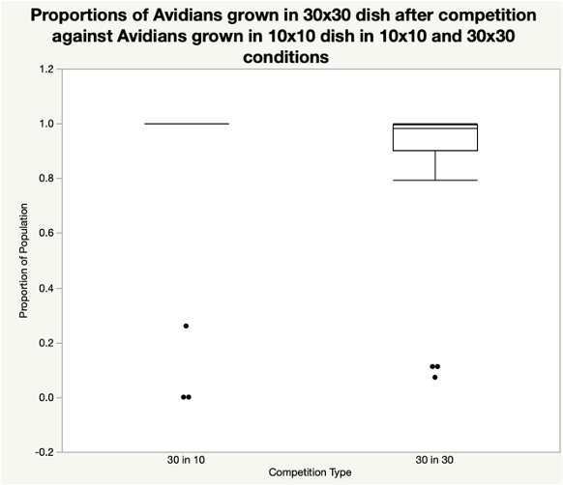

**Figure 1:** **Proportions of Avidians grown in 30x30 dish after competition against Avidians grown in 10x10 dish in 10x10 and 30x30 conditions:** This boxplot presents the proportion of 30x30 grown Avidians after 1,000 updates of competition in 10x10 and 30x30 dishes.

*Resource Competition*

In a resource free environment, an Avidian who had evolved in that same environment outcompeted an Avidian that had evolved in an environment with all resources, occupying 73% of the dish on average after 1,000 updates. In an environment with all resources present, the Avidian that had evolved in the same environment outcompeted the Avidian that evolved in a resource free environment, occupying 97% of the dish on average after 1,000 updates. These results were statistically significant at 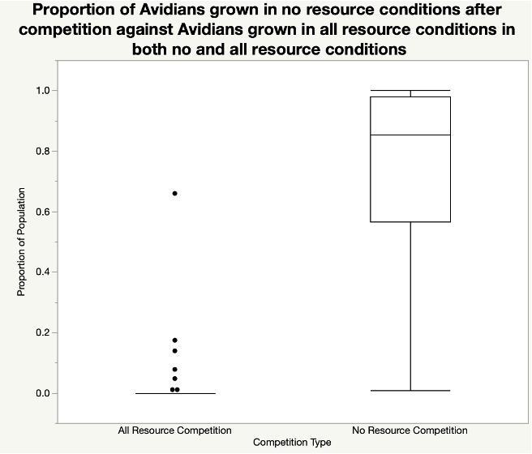

an alpha level of 0.05 (t=5.85, p<0.0001; t=31.78, p<0.0001)

**Figure 2:** **Proportions of Avidians grown in resource-free conditions after competition against Avidians grown in all resource conditions in both all and no resource conditions.** This boxplot presents the proportion of no resource grown Avidians after 1,000 updates of competition in both all and no resource environments.

**Discussion**

Our experiment sought to determine if organisms perform better when they are competing in an environment that is the same size as the environment they evolved in, in the context of dish size and resource availability. When an organism that evolved in a small dish competed against one that evolved in a large dish, the large-dish organism always outcompeted the other, regardless of dish size. Based on our observations, it seems that the average fitness of a large size dish is much higher than a small dish after the same amount of time. Thus, regardless of the competition environment the organism that grew in a large dish always fares better. Additionally, the average fitness and fitness spread of the larger dish were larger than the average fitness of the smaller dish. These data did not support our hypothesis of organisms faring better in the dish size they grew up in.

The finding that larger areas produce more fit organisms can be seen outside of the digital lab bench. Ecologists have long studied diversity on islands and observe that larger islands have greater biodiversity and are able to support more species (Helmus et al, 2014). Although all organisms in this experiment were the same, the increased variance in fitness level, and the overall higher fitness level in the large dish can be similarly attributed to the increase in space allowing for an increase in diversification.

For the competitions of this experiment, we chose to compete the fittest organism from each dish against each other. As previously stated, the larger dish had a larger fitness range and thus produced the most fit organism in each round of competition. This caused a potential limitation in our paper as we did not control for fitness size. However, further research could compete organisms with similar fitness values, testing which organisms fared better in eacg environment, which would prevent the limitation our experiment had. When the fitness values of competing organisms are more similar, it is possible that our hypothesis would be supported.

When we investigated if organisms fare better when competing in an environment with similar resources as to where they evolved, our hypothesis was supported: Organisms that evolved in a dish with all resources present outcompeted the organisms that evolved without resources when the competition environment had all resources present, and vice versa. The Avidians who evolved in the environment with all resources evolved to perform functions, specifically the ability to more effectively metabolize certain resources. The Avidians who evolved without resources did gain some ability to perform these functions, but at much lower rates than those who evolved with resources present. When competing in an environment with all resources present, the ability to perform functions was a large advantage. However, when no resources were present, the ability to perform functions was a maladaptation, and the Avidians who could do so were at a disadvantage because they were performing unnecessary cellular processes (Brady et al, 2019).

The idea that organisms perform best in the environment they evolved in is often seen in other parts of nature. For example, certain plants that have evolved in drier climates have evolved to use less water (Basu et al, 2016). If plants from a rainy area were placed in a dry area, they would almost certainly be outcompeted. However, this is not a rule as it is not true of invasive species, which perform best in environments where resources are high and are sometimes able to outcompete native plants, despite not being native to that environment (Funk et al, 2016).

The mutation rate in the competition portion of this experiment was set at 2%. However, if it was decreased or set to zero and the same experiment was run, conclusions could be drawn about the genetic vigor or frailty of the organisms that evolved in different environments, not just their ability to mutate to perform functions.

The results of our experiment show that organisms can evolve to become better suited to survive in a certain environment, as was especially seen in the context of resource availability. However, we also observed that some environments generally produce organisms that are more fit, as seen with the higher average fitness in a large dish compared to a small dish. Thus, we found that organisms won’t necessarily win competitions when in their native environment, but depending on the specific environmental parameter changed, they may still be better suited for competition there. Further examination of this phenomenon could help explain why some plant species are able to become invasive and outcompete native plants, despite not being in the environment they evolved in.